2024 Percy Pegler Swag Order Form
Please write in the quantity of each item you wish to order next to the size you wish to order
BLACK
T-Shirt $18
($5 off with the return of a previously loved Panther t-shirt)
Youth: S___ M___ L___ XL___ Adult: S___ M___ L___XL___

Youth Sweatshirts $35
Sizes: M___ L___ XL___
(NO SMALL, as the logo does not fit on the hoodie)

Adult Sweatshirts $40
Sizes: S___ M___ L___ XL___

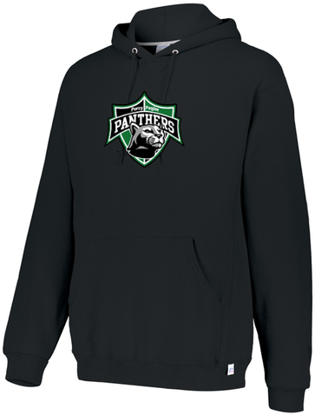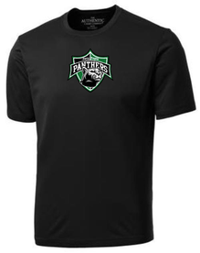

Kelly Green
T-Shirt $15
Youth: S___ M___ L___ XL___ Adult: S___ M___ L___XL___

Youth Sweatshirts $30
Sizes: M___ L___ XL___
(NO SMALL, as the logo does not fit on the hoodie)

Adult Sweatshirts $35
Sizes: S M L XL
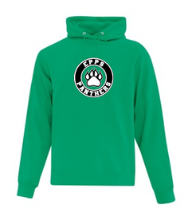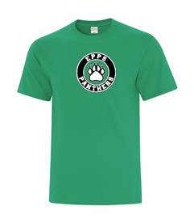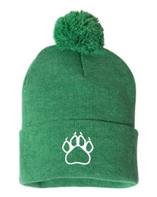
O/S Toque $25
Please use the student’s name you wish to have items sent home with.
Name of student:___________________________
Classroom teacher:__________________________

Payment Method: Please check below
Debit/Credit machine(in school only)____ Cash ____ Cheque ____ Edsembli ____

