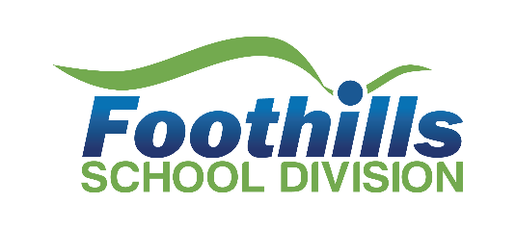
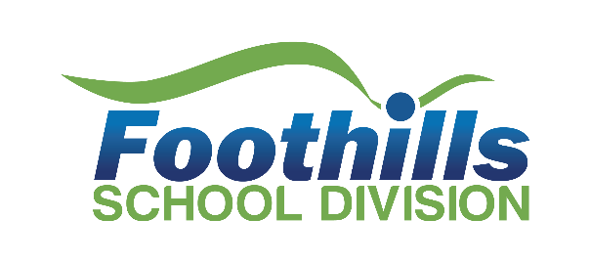
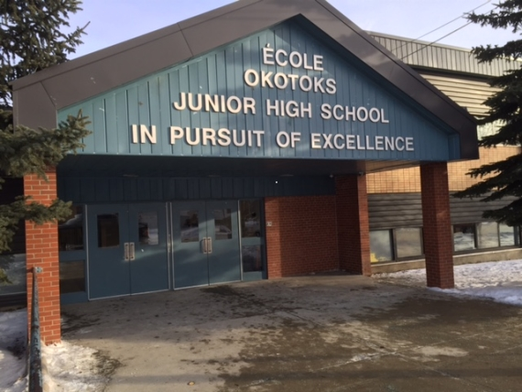
1 Pacific Ave Okotoks, AB T1S 1A9
403-938-4426
OJHS@fsd38.ab.ca
Okotoks Junior
2024 – 2025
Ecole Okotoks Junior High School

ANNUAL EDUCATION
RESULTS
REPORT
Education at the centre of a flourishing community.
foothillsschooldivision.ca

foothillsschooldivision.ca

Annual Education Results Report 2024-2025
Welcome to our Annual Education Results Report (AERR) for 2024-2025.
This is our story of engagement, support, and success for each learner.
Our Annual Education Results Report provides stakeholders with accurate, accessible, and easy to understand information on the progress of achieving goals as outlined in our 2024-2029 Education Plan. As part of a continuous improvement cycle, we have analyzed data, considered local context, developed insights, drawn conclusions, and identified next steps in advancing student growth and achievement. These results are used to report on our performance and to determine strengths, areas for growth and next steps. We share this information on an ongoing basis and seek input from students, staff, parents, and community. Key insights from results analysis outlined in this Annual Education Results Report informs next steps in our education plans and provides assurance to our stakeholders that we are advancing our priorities of engagement, support, and success for each learner.
ecole_okotoks_jr-_high_school-education-plan-2024-2029-year-1-1.6398e019873.pdf







LAND ACKNOWLEDGEMENT
We, the École Okotoks Junior High School community, acknowledge the traditional and ancestral lands of the Indigenous peoples of Treaty 7 territory, signed in 1877, on which this school is located, where we learn together, work together, and encourage each other to live in a good and respectful way.
We recognize, honour, and remember the Indigenous peoples who have lived here and continue to live on this land: the Siksika, Kainai, Piikani, Stoney-Nakoda, and Tsuut’ina. Okotoks is also home to the Rocky View District of the Otipemisiwak Métis Government for the Métis Nation within Alberta.
When we gather on this territory, we commit ourselves to learning how to be better lifelong learners, stewards of the land, and contributing members of this community.

FSD: We honour the spirit, life, and lessons this land and its ancestors teach us. We acknowledge the traditional land and territories of the Siksika, Piikani, Kainai, Tsuut’ina, and îyârhe Nakoda as well as the Foothills District and the Rocky View District within the Battle River Territory of the Otipemisiwak Métis government of Alberta.
Foothills School Division’s Truth and Reconciliation for Learner Success Toolkit

PRIORITIES
Engagement: Ensure and maintain Division wide engagement that is timely, meaningful, and collaborative with all learners and communities.
Support: Ensure and maintain Division wide learning environments that are welcoming, caring, respectful, safe, and inclusive.
Success: Ensure and maintain Division wide excellence in teaching, learning and leadership.
Board Policy 01: Division Foundational Statements
Board Policy 14: A Place for All

MISSION
Each learner entrusted to our care, has unique gifts and abilities. It is our mission to find out what these are...Explore them...Develop them...Celebrate them!

VISION
Engagement, Support, and Success for each learner.

PURPOSE
Education at the centre of a flourishing community.


System Thinking, Assurance and Accountability
Our story of assurance starts with systems thinking. Systems thinking propels our assurance actions. We explore possibilities and opportunities in developing strategies in new and complex perspectives to positively drive system change. Through this we make sense of the complexity. We get excited and challenged by change and thrive in new situations. Innovation demands that we set aside what we think we know, adopt a curious stance, and commit to learning and continuous improvement. We strive to make change for the better and do whatever we can to make that happen by identifying and enhancing models of educational excellence.
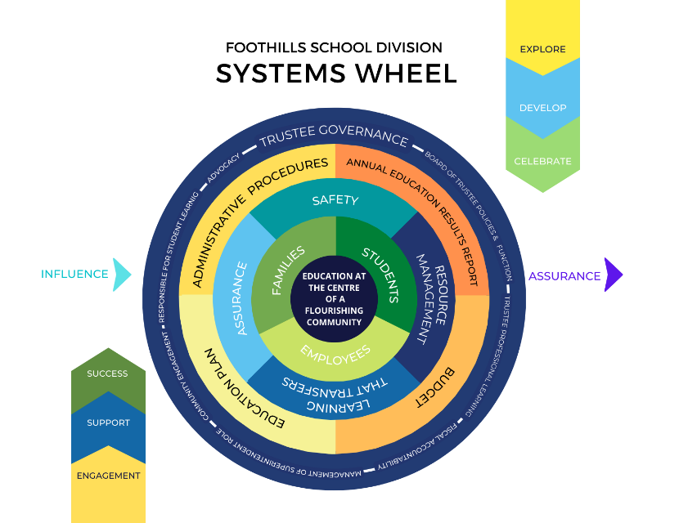
Our journey begins with systems thinking, which drives our actions. We explore new strategies and perspectives to create positive change. This helps us understand complexity, embrace change, and thrive in new situations. Innovation requires us to be curious, learn continuously, and improve. We aim to make positive changes by enhancing educational excellence.
Systems thinking is key to how we view the world, recognizing interrelationships, cycles, connections, and patterns over time. This approach has helped us build a shared vision, address opportunities, focus on team learning, understand our strengths, and strive for continuous growth. It has led us to place education at the centre of a flourishing community, influencing our actions, strategies, structures, and systems. We are a very strong school division integrated within the community, making decisions with engagement, support, and success for all.
This approach helps us see patterns and connections, align our actions, and advance our goals. Our Foothills School Division Systems Wheel illustrates the interconnected pieces of our system. External factors like provincial funding, the Education Act, and community voices, as well as internal influences like governance, procedures, and budgets, shape our system. Our outputs, such as the AERR, Capital Plan, and successful students, tell our story of interconnectedness.
Our approach to systems thinking and interconnectedness directly contributes to our flourishing learning community. This holistic approach allows us to build a shared vision and embrace opportunities together, fostering learning and continuous growth. By placing education at the heart of our community, we promote that our actions, strategies, and structures are aligned with our goal of creating a thriving educational environment.
Foothills School Division is responsible for providing assurance to our stakeholders and the public that we are fulfilling our responsibilities and students are successful. This assurance arises from the combination of policies, processes, actions, and evidence that help build public confidence in the education system. This is achieved through relationship building, engagement with education partners and by creating and sustaining a culture of continuous improvement and collective responsibility. Foothills School Division’s Education Plan and Annual Education Results Report (AERR) are evidence of a continuous improvement process and are core documents for demonstrating accountability and providing assurance. The Education Plan and AERR inform one another for continuous growth.
Our FSD strategic planning process is outlined in FSD AP 100: Education Plan and Annual Education Results Report and AP 101: Annual Education Results Report. Our five-year fixed education plan is aligned with Alberta Education’s Business Plan 2024-2027 and clearly identifies priorities and outcomes to be achieved, measures used to assess progress, and research and practice-informed strategies implemented to achieve goals. Our AERR provides the results obtained from implementing the plan and actions taken to meet responsibilities in the key assurance domains. By analyzing the results, we develop insights, draw conclusions, and determine implications arising from the results. We use results to improve the quality and effectiveness of education programs and improve student learning and achievement. Areas that are identified as needing improvement, along with stakeholder engagement input and provincial direction, are reflected in the outcomes and strategies in the education plan. Division priorities and processes provide strategic direction to schools in the development of their plans and in engaging stakeholders on an ongoing basis to provide assurance in advancing goals. This is outlined in AP 118: Annual Assurance Actions and AP 102: School Annual Education Plan Results Report. Engaging with our stakeholders has been critical in the development and implementation of our education plan and annual education results report. Effectively engaging stakeholders in the development of our education plan and sharing results has contributed to shared governance, being more responsive to local needs; increasing stakeholder understanding of education matters; and improving decision making.

School Councils Regulation
Section 12(1) of the School Councils Regulation under the Education Act requires school boards to provide school councils with the opportunity to provide advice on the development of the school’s foundational statements (vision, principles, and beliefs); Education Plan; annual results report; and budget. Section 12(2) requires school boards to provide the school council with the results for the school from provincial assessments and an interpretation of those results as well as the information that the board disseminates through its reporting and accountability system per Section 67 of the Education Act..

Alignment of Provincial Outcomes , Assurance, Domains & Foothills School Division Goals
Alberta Education Outcomes  Education Ministry Business Plan  2024-27 | Foothills School Division Goals  Foothills School Division Education Plan 2024-29 | Assurance Domains  Alberta Education Funding Manual  2024-25
- Alberta’s students are successful | - Learning that transfers  - Numeracy and literacy  - Wellness and wellbeing  - Continuum of supports | - Student growth & achievement  - Learning support
- First Nations, Métis, and Inuit students in Alberta are successful | - First Nations, Métis, and Inuit student success | - Student growth & achievement  - Learning support
- Alberta’s students have access to a variety of learning opportunities to enhance competitiveness in the modern economy | - Innovation and design  - Learning that transfers  - Excellence in teaching, learning, and leading | - Student growth & achievement  - Teaching and leading  - Local and societal context
- Alberta’s K-12 education system and workforce are well-managed | - Stakeholder engagement and communications  - Continuous improvement and assurance | - Local and societal context  - Governance

Our Goals & Assurance Measures
Engagement | Support | Success
Local and Societal Context | Learning Supports | Student Growth and Achievement
Goal  - Advance Stakeholder Engagement and Communications  Assurance Measure  FSD provides trust and confidence that the education system responds proactively to local and societal contexts. | Goals  - Advance Wellness and Well-being  - Advance Continuum of Supports  Assurance Measure  FSD provides confidence that resources are managed effectively in establishing learning environments where local and societal context is recognized, diversity is embraced, a sense of belonging is emphasized and all students are welcomed, cared for, respected and safe. | Goals  - Advance Innovation and Design  - Advance Learning for Transfer  - Advance Literacy and Numeracy  - Advance First Nations, Métis, and Inuit student success  Assurance Measure  FSD provides trust and confidence that students demonstrate citizenship, engage intellectually, and grow continuously as learners.
Governance | 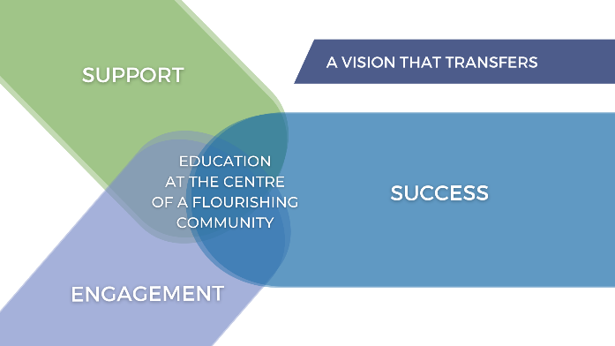 | Teaching and Leading
Goal:  - Advance Continuous Improvement and Assurance  Assurance Measure  FSD provides trust and confidence that policy leaders demonstrate stewardship of system resources with an emphasis on student success, generative community engagement, transparency, and accountability. |  | Goal  - Advance Excellence in teaching, learning and leading.  Assurance Measure  FSD provides trust and confidence that certified teachers and certified leaders demonstrate their respective professional practice standards (Teaching Quality Standard, Leadership Quality Standard, and Superintendent Leadership Quality Standard).

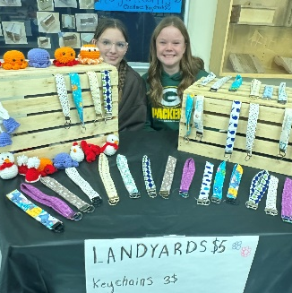
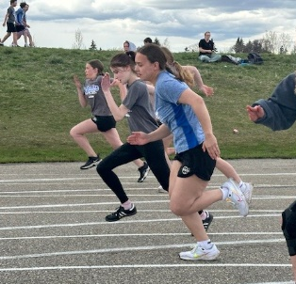
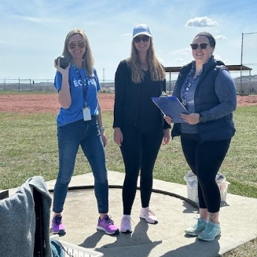
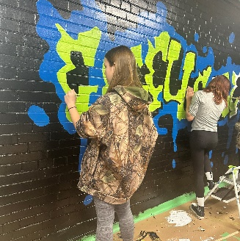
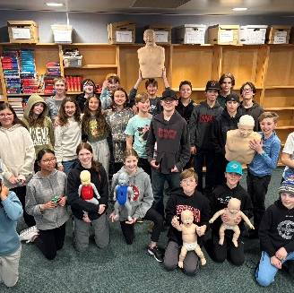

Our School
École Okotoks Junior High School is a grade 7-9 school with approximately 425 students and 32 staff. Our school has certificated teachers including a Learning Coach, as well as non-certificated staff such as educational assistants, office staff, a Learning Commons Facilitator, and a Family School Liaison Counselor. We are a dual track school offering French Immersions Program as well as English classes. We offer a wide range of learning opportunities in the classroom, community and outdoors. Students are invited to attend a variety of clubs and extracurricular activities, for a well-rounded schooling experience focusing on intellectual engagement, health & well-being, and social emotional development. To develop the whole child and prepare them for life beyond the walls of schools, we offer a variety of Career and Technology Foundations (CTF), Fine Arts and physical activity opportunities. This provides students the opportunity to explore their interests within various occupational areas and technologies. Through CTF, students may plan, design, create, and implement solutions for relevant problems that exist in our world. These include construction, foods, sports performance, textiles, digital design, band, choir, guitar, outdoor education, makerspace, and drama to name a few. We are the home of the Ocelots. “In pursuit of excellence”


Highlights and Celebrations
2024-2025 school year brought many learning opportunities for students that extended beyond the classroom. Band and Musical Theatre students travelled to Disneyland where they took part in clinics and workshops. Our Guitar students travelled to Nashville where they got to experience the many aspects of the music industry from behind the scenes at the Grand Ol Opry, performing, writing and recording music, etc. In the Career and Technology Foundations field students had the opportunity to participate in the Skills Expo where they were given a challenge and had to work together to design a real-life solution to the challenge. Our Outdoor expedition program saw three groups of students go camping in the backcountry in Kananaskis country. Academically, our students continue to excel which was evident in our year end Academic Awards Ceremony where students were recognized for achieving Honour Roll, Academic Excellence, and subject specific awards. Our French Immersion grade 9 students passed the DELF Exam. Students were provided opportunities to participate in a variety of athletics ranging including cross country, football, volleyball, basketball, badminton and track and field. Some of the highlights included league wins, tournament wins, and personal bests.
December 2025 Review

Education Assurance Measures Report Summary
Alberta Education Assurance Survey: Provincial reporting of staff, student, and parent attitudes to learning within the domains of student growth and achievement, teaching and leading, learning support and governance.
AEAM Summary by Stakeholder Group (Parents/Students/Staff)
Assurance Measures Overall | Student Learning Engagement | Citizenship | Education Quality | Safe, Caring & Welcoming | Access to Supports | Parental Involvement | School Improvement
2021-2022 (School) | 80.9% | 60.3% | 81.1% | 71.0% | 77.1% | 55.5% | 57.4
2021-2022 (Prov) | 85.1 | 81.4 | 89 | 86.1 | 81.6 | 78.8 | 74.2
2022-2023 (School) | 83.1% | 66.1% | 85.8% | 75.5% | 76.1% | 68.9% | 66.8
2022-2023 (Prov) | 84.4 | 80.3 | 88.1 | 84.7 | 80.6 | 79.1 | 75.2
2023-2024 (School) | 81.8% | 58.9% | 79.7% | 68.5% | 73.8% | 74.6% | 80.4
2023-2024 (Prov) | 83.7 | 79.4 | 87.6 | 84.0 | 79.9 | 79.5 | 75.8
2024-2025 (School) | 79.9% | 75.7% | 86.4% | 82.9% | 79.6% | 72.5% | 78.7
2024-2025 (Prov) | 83.9 | 79.8 | 87.7 | 84.4 | 80.1 | 80.0 | 76.6
Evaluation (Achievement) | Low | Intermediate | Intermediate | Intermediate | Intermediate | Low | High
Evaluation (Improvement) | Maintained | Improved Significantly | Improved | Improved Significantly | Maintained | Maintained | Improved Significantly
FSD Assurance Survey (Parent): Parent attitudes to learning in the domains of student growth and achievement, teaching and leading, learning support and governance.
Assurance Measures | Student Learning Engagement | Citizenship | Education Quality | Safe, Caring & Welcoming | Access to Supports | Parental Involvement | School Improvement
2021-2022 | 86 | 62 | 94 | 67 | 80 | 65 | 51
2022-2023 | 88 | 62 | 94 | 66 | 83 | 70 | 53
2023-2024 | 83 | 71 | 82 | 81 | 82 | 64 | 64
2024-2025 | 68 | 86 | 84 | 90 | 84 | 80 | 81
Evaluation | LOW | HIGH | HIGH | HIGH | HIGH | INTERMEDIATE | INTERMEDIATE

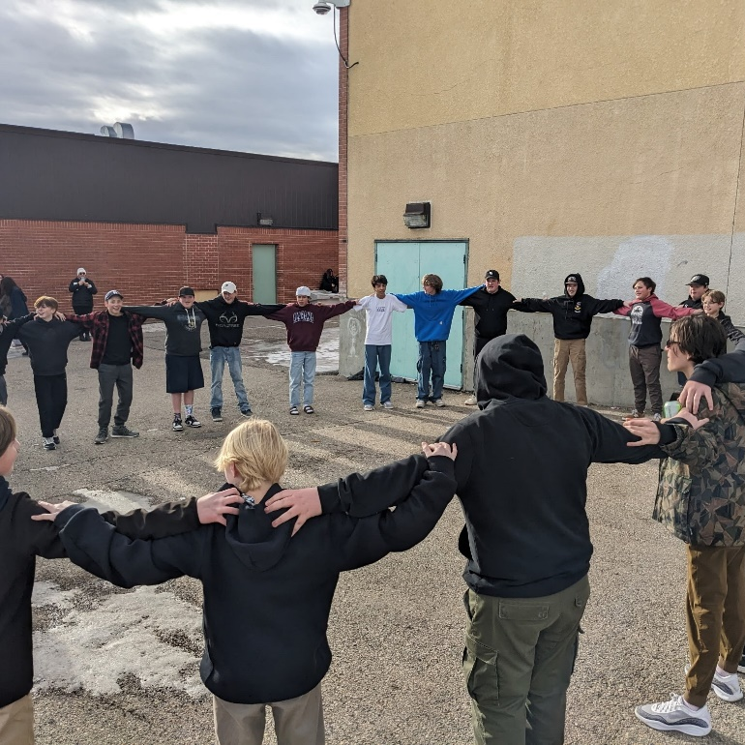
OUR STORY OF ENGAGEMENT

EOJHS focuses on strengthening stakeholder engagement and supporting evidence-based continuous improvement. Key actions include using tools to target education partners, gather feedback, and report back on how their input influences decisions. The school will share its Education Plan with the School Council and maintain consistent weekly communication with the community, highlighting responses to feedback.
For continuous improvement, the school uses triangulated evidence to guide decisions, measure and analyze results to identify areas for growth, and develop effective engagement processes that adapt to participant needs. Successes will be communicated to ensure accountability, and capacity-building opportunities will support ongoing improvement. Overall, the approach emphasizes transparent, responsive, and collaborative decision-making.

90%
of parents indicate EOJHS is a Safe Caring and Welcoming school.
(FSD Assurance Survey)
86%
of students, parents and staff indicate the Education Quality is at an acceptable standard.
(Alberta Education Assurance Survey)

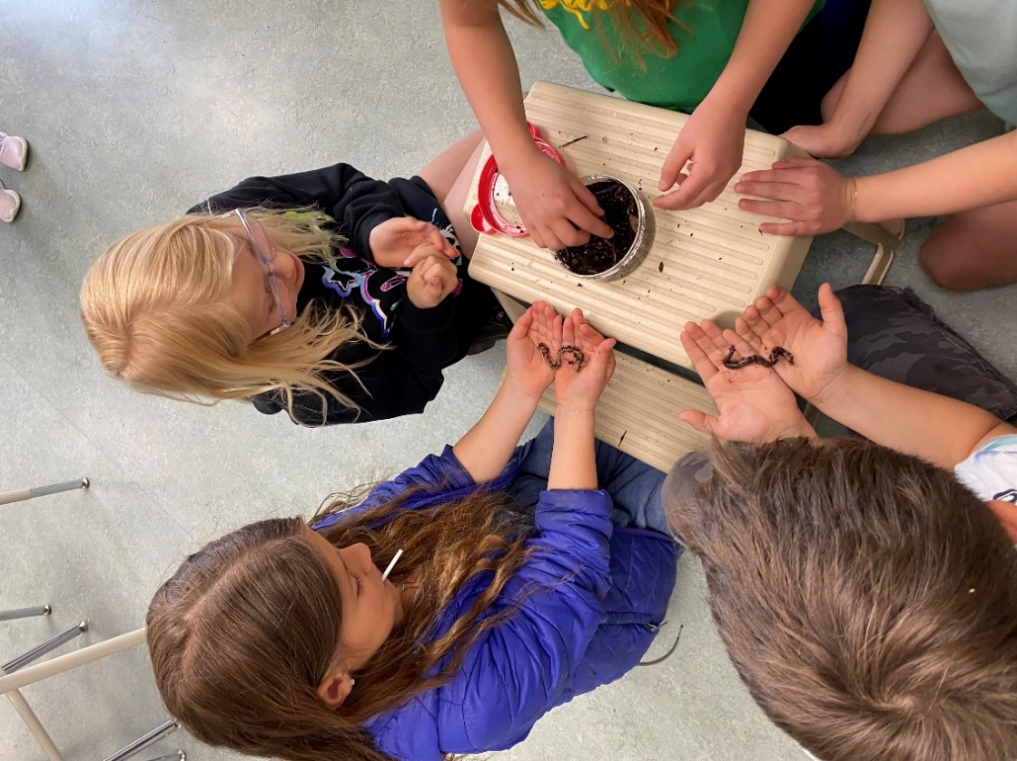
80%
of students, parents and staff indicate they are satisfied with Student Learning Engagement.
(Alberta Education Assurance Survey)
83%
of parents indicate the School Improvement is at an acceptable standard.
(FSD Assurance Survey)
Support Opportunities & Resources
- Policy 14: A Place for All
- Safe Positive Schools
- FSD Resilience
- Inclusive Learning
- Student Learning
- Indigenous Learning

91%
Parents indicate our schools are safe and caring spaces
(FSD Assurance Survey)
89%
Students report our schools are safe and caring spaces
(SOS-Q)
84%
Parents indicate students have access to supports
(FSD Assurance Survey)

87%
Students report positive peer relationships
(SOS-Q)

- Indigenous Learning
- Student Supports
- Supports for Families
- Community Supports

Engagement Opportunities & Resources
- Policy 1: Divisional Foundation Statements
- Advocacy
- A Shared Responsibility: Safety for All
- Celebrations for All
- Celebrating our Flourishing Community
- Engagement Opportunities
- Foothills Flourishing Community Award
- FSD Footnotes
- FSD Social Media
- FSD News
- Get Involved
- Governance

100%
Participants agree that Belonging is an element of flourishing. As such, welcoming communities are a shared responsibility.

ENGAGEMENT
Goals | Outcomes | Indicators | MEASURES
Advance stakeholder engagement and communications  Advancing stakeholder engagement practices and communication strategies will ensure FSD is responsive to local needs, it increases stakeholder understanding of education matters and improves decision-making. It will provide stakeholders with accurate, accessible, and easy to understand information about the progress and performance of FSD in relation to provincial assurance domains and division priorities of engagement, support, and success for each learner. | - Actively engage stakeholders to inform the development of local priorities and plans drawing upon a variety of sources to measure engagement:  - What stakeholders were involved?  - How they were engaged?  - How their input informed local priorities?  - School boards actions to meet its obligations under section 12 of the School Councils Regulation to provide opportunity for School Councils to be involved in developing School Education Plans.  - Education partners anticipate local and societal needs and circumstances and respond with flexibility and understanding. | - Measures demonstrate stakeholder engagement informs policies, procedures, priorities, education plans, annual education results reports and budget decisions in support of student growth and achievement.  - Measures demonstrate that stakeholders actively participate in engagement opportunities provided by Foothills School Division. | - Parent Involvement (AEAM): Increase/maintain in percentage of teachers and parents satisfied with parental involvement in decisions about their child's education.  - School Improvement (AEAM): Increase/maintain percentage of teachers, parents and students indicating that their school and schools in their jurisdiction have improved or stayed the same the last three years.  - Quality of Education (AEAM): Increase/maintain percentage of teachers, parents and students satisfied with the overall quality of basic education.  - Stakeholder Engagement: Increase/maintain participation of stakeholders to inform decisions.  - FSD Assurance Survey: Increase/maintain
Advance evidence-based continuous improvement and assurance  Learners will communicate, collaborate, and solve problems together to advance education excellence and provide assurance for student growth and achievement. | - Establish a system of accountability practices which include guiding principles for assurance at a division and school level.  - Use results to improve the quality and effectiveness of education programs provided to students and to improve student learning and achievement.  - Sustained culture of continuous improvement and collective responsibility.  - A cycle of evidence-based continuous improvement that informs ongoing planning and priority setting, builds capacity.  - Governors engage students and their families, staff and community members in the creation and ongoing implementation of a shared vision for student success.  - Legislation, policy, and regulation provides clarity regarding the roles and responsibilities of education partners in matters of governance.  - Fiscal resources are allocated and managed in the interests of ensuring student success, in alignment with system goals and priorities and in accordance with all statutory, regulatory and disclosure requirements.  - Curriculum is relevant, clearly articulated and designed for implementation within local contexts.  - Governors in school authorities and in government employ a cycle of evidence-based continuous improvement to inform ongoing planning and priority setting, and to build capacity.  - Engagement of parents, students, staff, and other key stakeholders on board matters and plans contribute to shared governance. | - Measures indicate learners communicate, collaborate, and solve problems together to advance education excellence and provide assurance for student growth and achievement (explore, develop, take action, and evaluate).  - The Education Plan and Annual Education Results Report (AERR) represent evidence-informed decision making and continuous improvement.  - FSD provides accountability to the Department of Education that we are fulfilling our responsibilities of providing education programs for K-12 students.  - FSD provides assurance to local stakeholders and the public that we are fulfilling our responsibilities and that students are successful.  - AERR data is analyzed, local and societal context considered, insights developed, and conclusions drawn to inform education plans.  - Governance responsibilities reflect a student-centered focus and principles of inclusiveness, fairness, diversity, and excellence.
Results Analysis for Engagement | Previous Results (4-Year Data Trends and Key Insights)
Alberta Education Assurance Survey: Provincial reporting of staff, student, and parent attitudes to learning within the domains of student growth and achievement, teaching and leading, learning support and governance.
Provincial Performance Measure | Education Quality | Parental Involvement | School Improvement
2024-2025 (School) | 86.4 | 72.5 | 78.7
2024-2025 (Prov) | 87.7 | 80 | 76.6
Evaluation (Achievement) | INTERMEDIATE | LOW | HIGH
Evaluation (Improvement) | IMPROVED | MAINTAINED | IMPROVED SIGNIFICANTLY
FSD Assurance Survey (Parent): Parent attitudes to learning within the domains of student growth and achievement, teaching and leading, learning support and governance.
Assurance Measures | Education Quality | Parental Involvement | School Improvement
2024-2025 | 84 | 80 | 83
Evaluation  Education Quality  Your child finds schoolwork challenging  Your child is learning what they need to know​  The quality of education your child is receiving at school​  Your child clearly understands what they are expected to learn at school​  Your child finds schoolwork interesting  OUTCOMES TO CONSIDER | HIGH  Parental Involvement  To what extent are you involved in decisions about your child's school  The opportunities to be involved in decisions about your child's overall education ​  The opportunities to be involved in decisions about your child's school​  To what extent are you involved in decisions about your child's overall education  Your input into decisions about your child's school is considered | HIGH  Has the quality of education that your child experienced at school improved, stayed the same, or declined in the past three years  School Improvement | HIGH

Strategy Analysis
Strategy Implemented in 2024-2025 2025-2026 2026-2027 2027-2028 2028-2029
Stakeholder Engagement and Communications | EVALUATION
Strategy 1: We will share our Ed Plan and how we are meeting our goals with School Council | VERY HIGH
Strategy 2: We will continue weekly communication with the community, parents, teachers and students, and sharing our response to their feedback | VERY HIGH

Data AnalysiS
In telling our story of engagement we looked at the progress we made in advancing our goals of stakeholder engagement and continuous improvement. We looked at the data we gathered from both the Alberta Education and FSD Assurance Surveys in the specific areas of education quality, parental involvement, and continuous improvement as well as opportunities for stakeholder engagement in Foothills School Division. The data told us that
- Parental Involvement improved to 72.5% up +6.2%, but still trails the provincial average—so continued focus is warranted
- Strong engagement and connection between the school and community is evident in partnerships such as Okotoks Elks Club, Okotoks Fish and Wildlife, The Okotoks Canadian Legion Branch Imagine a Canada Grant, Western Financial Grant and business partnerships including Classic Cycle and Integrity Building Systems.
- Student Matters Committee plays a significant role in gathering student voice and implementing plans of action
- 18% increase in parents, students and teachers who are satisfied with the overall quality of education at EOJHS
- School Improvement is our biggest mover: 78.7 vs 60.6 three-year average, an +18.1-point gain.
- The Development of a School Leadership team to plan and guide decisions made regarding the staff learning plan has increased teacher satisfaction in Professional Learning days.

Continuous Improvement and Assurance | EVALUATION
Strategy 1: Measuring, analyzing and reporting results and using results to identify areas for improvement | HIGH
Strategy 2: Celebrate and communicate successes and accomplishments to ensure accountability and provide assurance for continuous improvement. | VERY HIGH
Strategy 3: Consistently use evidence from a variety of sources to ensure responsive and transparent decision-making | HIGH
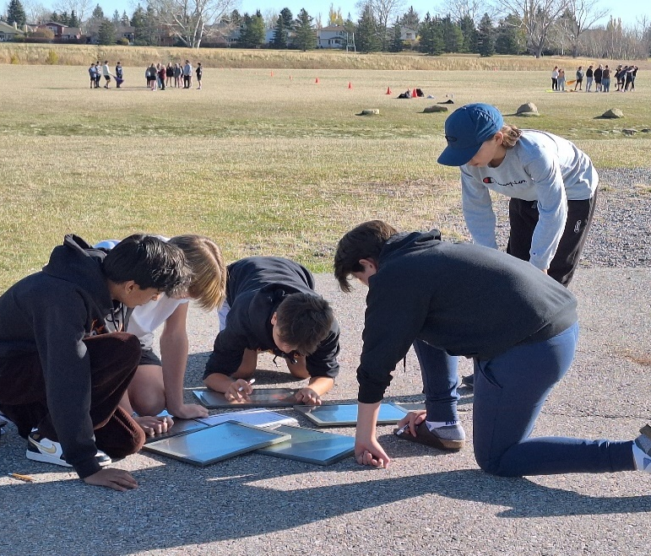

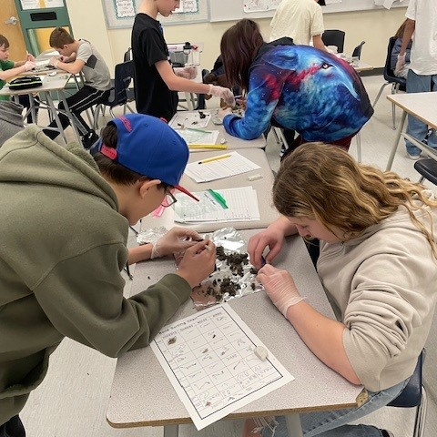
OUR STORY OF SUPPORT

EOJHS aims to strengthen student wellness and well-being by continuing to build a trauma-informed, inclusive school culture and emphasizing social-emotional learning. Supports such as the Minds Matter team will be expanded, and a new Speaker Series will promote kindness, empathy, and address bullying. Data from Student Matters and the SOS-Q will guide improvement efforts, and the washroom beautification project will be extended to Grade 8 spaces.
To enhance the continuum of supports, the school will further develop a comprehensive system addressing students’ social, emotional, physical, and academic needs. Stakeholder voice will continue to be gathered through tools like Students’ Matters, the SOS-Q, and engagement surveys, while parent communication will be strengthened to build understanding of student needs and available supports.

84%
of parents indicate that EOJHS students have Access to Supports and Services.
(FSD Assurance Survey)
87%
of parents indicate that EOJHS is Safe & Caring.
(FSD Assurance Survey)

Support Opportunities & Resources
- Policy 14: A Place for All
- AP 309 Safe, Caring, Respectful, and Inclusive Learning Environments that Foster a Place for All
- A Flourishing Community
- Celebrating our Flourishing Community
- Parent and Community Connect
- Inclusive Learning
- Student Learning
- Support for Parents
- Truth and Reconciliation for Learner Success Toolkit

89%
of students indicate they have positive Peer Relations.
(SOS-Q)
84%
of students indicate they have External Resilience skills.
(SOS-Q)
Support Opportunities & Resources
- Policy 14: A Place for All
- Safe Positive Schools
- FSD Resilience
- Inclusive Learning
- Student Learning
- Indigenous Learning

91%
Parents indicate our schools are safe and caring spaces
(FSD Assurance Survey)
89%
Students report our schools are safe and caring spaces
(SOS-Q)
84%
Parents indicate students have access to supports
(FSD Assurance Survey)

87%
Students report positive peer relationships
(SOS-Q)

- Indigenous Learning
- Student Supports
- Supports for Families
- Community Supports

create welcoming, safe, caring, inclusive and respectful environments that are trauma informed and responsive to the needs of students and Support
Goals | Outcomes | Indicators | Measures
Advance wellness and well-being  Collaboratively promote and advance healthy school environments for all, based upon a strong foundation of wellness and well-being. | - All stakeholders contribute to a welcoming, caring, respectful and safe school environment.  - Wrap around services and supports enhance healthy school environments for student well-being and staff wellness.  - Students and staff better understand mental health and resilience and the role they play in their own positive mental health and resilience.  - Schools continue to implement and advance trauma-informed practices to contribute to healthy school environments. | - Measures indicate that students and staff have a sense of belonging at school, resulting in higher attendance and engagement.  - Measures indicate that students and staff respect one another and take responsibility for their own actions.  - Measures indicate that students and staff have choice and strive for excellence within a healthy school environment.  - Measures indicate that students and staff are generous to one another and recognize the positive contributions everyone makes to the healthy school environment. | - Safe & Caring (AEAM): Increase/maintain the percentage of teachers, parents and students who agree that students are safe at school, are learning the importance of caring for others, are learning respect for others, and are treated fairly in school.  - Program Access (AEAM): Increase/maintain the percentage of teacher, parent and student satisfaction with the accessibility, effectiveness and efficiency of programs and services for students in their community.  - Students at Risk (AEAM): Increase/maintain the percentage of teachers, parents and students agree that programs for children at risk are easy to access and timely.  - SOS-Q (Student Orientation to School Questionnaire): Increase/maintain in percentage of students who are at or above the National Norm in the areas of Safe and Caring, External Resilience, Internal Resilience, Self-Confidence, Peer Relationships, Utility of School and Extracurricular Activities.
Advance our Continuum of Supports  Collaboratively engage all stakeholders in creatively expanding and implementing the continuum of supports within each local context. | - A robust continuum of supports ensures student success.  - Learning environments are adapted as necessary to meet learner needs, emphasizing a sense of belonging and high expectations for all.  - Learners demonstrate understanding and respect for the uniqueness of all learners.  - Learning environments are welcoming, caring, respectful and safe.  - Structures and systems support learning and meet the needs of students, families, staff, and communities.  - Learners access continuum of supports.  - Wrap around services and supports enhance conditions required for optimal learning.  - Education partners fulfil their respective roles for a shared understanding of an inclusive education system.  - All stakeholders work collaboratively to support student learning. | - Measures indicate that each learner has access to programs, services, and strategies within the continuum of supports that are consistent with the principles of inclusive learning.  - Continuum of Supports is visible and accessible.  - Measures indicate that teachers, parents, and students report that learning environments are welcoming, caring, respectful, and safe.

Results Analysis for Support | Previous Results (4-Year Data Trends and Key Insights)
Alberta Education Assurance Survey: Provincial reporting of staff, student, and parent attitudes to learning within the domains of student growth and achievement, teaching and leading, learning support and governance.
Provincial Performance Measures | Safe and Caring | Access to Supports and Services  (students ‘at risk’)
2024-2025 (School) | 86.9 | 79.6
2024-2025 (Prov) | 87.3 | 80.1
Evaluation (Achievement) | HIGH | INTERMEDIATE
Evaluation (Improvement) | IMPROVED SIGNIFICANTLY | MAINTAINED
At school, there are appropriate supports and services available to your child to help with their learning​
You can get the support you need from the school to help your child be successful in their learning
When your child needs it, teachers at your child's school are available to help them ​
Access to Supports and Services
OUTCOMES TO CONSIDER
Your child can get help at school with problems that are not related to schoolwork ​
Your child can easily access programs and services at school to get help with schoolwork
Your child can get help at school with problems that are not related to schoolwork
Your child can easily access programs and services at school to get help with schoolwork
When your child needs it, teachers at your child's school are available to help them ​
Program of Studies: At-Risk Students
FSD Assurance Survey (Parent): Parent attitudes to learning within the domains of student growth and achievement, teaching and leading, learning support and governance.
Provincial Performance Measures |  |  | Safe and Caring |  |  | Access to Supports and Services  (students ‘at risk’)
2024-2025 |  |  | 87 |  |  | 84
Evaluation |  |  | HIGH |  |  | HIGH
FSD SOS-Q Survey (Student) (Student Orientation to School Questionnaire): This survey is used to identify student’s degrees of connectivity to school in a variety of dimensions and assist with initiating strategies to re-connect students that may be disengaging from school. The survey results allow schools to look at trends across the school and grades as well as dig into individual student responses.
above national norm
 | Safe & Caring | External Resilience |  | Self Confidence | Internal Resilience |  | Peer Relations
2024-2025 | 85.4 | 83.9 |  | 74.9 | 62.2 |  | 88.8
Evaluation | HIGH | HIGH |  | INTERMEDIATE | INTERMEDIATE |  | HIGH

Strategy Analysis
Strategy Implemented in 2024-2025 2025-2026 2026-2027 2027-2028 2028-2029
Wellness and Well-being | EVALUATION
Strategy 1: Continue to emphasize the building of a trauma-informed culture for students as part of creating healthy school cultures and inclusive learning environments. | HIGH
Strategy 2: Continued focus on social emotional learning to support student well-being.  - Continue to expand the support of the Minds Matter team in our classrooms.  - Create a Speaker Series that encourages kindness and empathy and addresses bullying. | INTERMEDIATE
Strategy 3: Continue to leverage Student Matters and the Student Orientation to School Questionnaire (SOS-Q) data to identify areas of growth and develop creative solutions to address these areas of growth.  - Expand the washroom beautification project to the Grade 8 washrooms. | HIGH
Continuum of Supports | EVALUATION
Strategy 1: Continue to implement, refine, and expand the continuum of support based on current student profiles to address social, emotional, physical, and academic growth for students. | HIGH
Strategy 2: Continued support of stakeholder voice through various platforms including, but not limited to, Students’ Matters, SOS-Q Survey, and Engagement Survey | VERY HIGH
Strategy 3: Continued and enhanced parent communication to develop understanding of student areas for growth and supports available | HIGH
OUTCOMES TO CONSIDER
Students at your child's school care about each other

Welcoming, Caring, Respectful and Safe Learning Environments
Students at your child's school respect each other

Students treat each other well at your child's school
Teachers care about your child

Your child is safe at school

Your child is safe on the way to and from school

Your child is treated fairly by adults at school at school​

Data Analysis
In telling our story of support we look at the progress we made in advancing our goals of wellness and well-being and continuum of supports. We looked at the data from both the Alberta Education(All students grades 4-12, parents grades 4, 7, and 10, and all teachers) and FSD Assurance Surveys (All parents) in the specific areas of safe and caring and access to supports as well as SOS-Q measures of safe and caring, external resilience, self-confidence, internal resilience, and peer relations for our students in grades 4 through 12. This data told us that:
- Our focus on building a Trauma informed culture and an inclusive learning environment has resulted in a consistent improvement in Citizenship, Education Quality, and Welcoming Environments.
- Citizenship rose from 61.8% to 75.7%,
- Education Quality from 82.2% to 86.4%, and
- Welcoming, Caring, Respectful Learning Environment CRSLE from 71.7% to 82.9%.
- We also see steady gains in access to Supports (79.6, +3.9.
- These upward trends demonstrate the impact of targeted interventions and our commitment to continuous improvement
- These trends demonstrate the positive effects that initiatives such as the bathroom beautification by Student Matters and inviting guest speakers from the RCMP about Social Media and Internet safety contributes to our safe and caring environment.

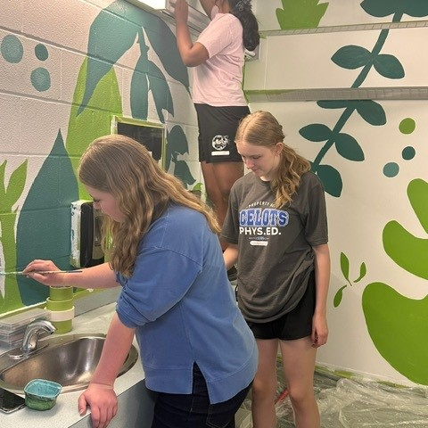
OUR STORY OF SUCCESS:
Innovation and Design
Learning that Transfers

EOJHS aims to strengthen innovation and design by supporting teachers in creating learning experiences that foster conceptual understanding, deeper thinking, student agency, and a lifelong love of learning. It also includes expanding innovative CTF programs such as Codebotics, Makerspace, and Digital Design, while building staff capacity to lead these initiatives at both school and system levels.
To advance learning that transfers, the school will develop meaningful, real-world learning tasks and deepen understanding of effective assessment and reporting practices. Assessment will draw on multiple forms of evidence—observations, conversations, and products—and students will be active participants in the process, able to identify their strengths, growth areas, and next learning steps.

95%
of parents indicate the Program of Studies is within the domains of student growth and achievement, teaching and leading, learning support and governance.
(FSD Assurance Survey)

84%
of students, parents, staff indicate Work Preparation meets an acceptable standard.
(Alberta Education Assurance Survey)

Evidence of Success & Resources
- Innovation and Design
- Learning that Transfers

94%
of students indicate EOJHS has High Expectations for student success.
(Intellectual Engagement Survey)
82%
of students indicate they are engaged in learning in CTF.
(Intellectual Engagement Survey)
Support Opportunities & Resources
- Policy 14: A Place for All
- Safe Positive Schools
- FSD Resilience
- Inclusive Learning
- Student Learning
- Indigenous Learning

91%
Parents indicate our schools are safe and caring spaces
(FSD Assurance Survey)
89%
Students report our schools are safe and caring spaces
(SOS-Q)
84%
Parents indicate students have access to supports
(FSD Assurance Survey)

87%
Students report positive peer relationships
(SOS-Q)

- Indigenous Learning
- Student Supports
- Supports for Families
- Community Supports

STUDENT GROWTH AND ACHIEVEMENT
INNOVATION AND DESIGN AND LEARNING THAT TRANSFERS
GOALS | OUTCOMES | INDICATORS | MEASURES
Advance innovation and design  Build on existing high-quality learning in FSD by cultivating a culture of innovation and design to deepen student understanding of knowledge, skills and learning competencies through robust programs and career exploration that develops life-long learners and active citizens that are prepared for the future. | - Students have access to a variety of learning opportunities to enhance competitiveness in the modern economy.  - Provide innovative learning opportunities to ensure a variety of career pathways for students to enter post-secondary education or their chosen fields in the workforce.  - Provide career education programming that enables students to explore and experience various occupations.  - Explore strategies to enhance the apprenticeship system for students interested in pursuing training in the skilled trades, in partnership with other ministries.  - Continue to support collegiate school opportunities including Dual Credit to create more pathways for students to post-secondary education and the workforce.  - Learning is robust and applies knowledge, understanding and skills in authentic contexts and situations.  - Student experiences are designed for deep and transferrable learning.  - Schools K-12 advance a culture of innovation and design where learners leverage design thinking and creativity while exploring career futures.  - Learners demonstrate the competencies to prepare them for their future.  - Innovation and Design and Career Futures Frameworks enrich learning and meet the needs of learners. |  | - Measures indicate learners are successful in maker-centered, career foundations technology and career technology studies that engage learners in authentic, real-world, experiential, hands-on learning environments and experiences.  - FSD collaborates with community, industry, and education partners to support student success.  - Learners demonstrate transfer of learning through a variety of off campus and learning opportunities including Work Experience, Registered Apprenticeship Program, Green Certificate, Skilled Trades opportunities and Post-Secondary Dual Credit partnerships.  - Measures indicate that learners are intellectually engaged in their learning. | - Student Learning Engagement (AEAM): Increase/maintain percentage of teachers, parents and students satisfied students are engaged in their learning at school.  - Program of Studies (AEAM): Increase/maintain percentage of teachers, parents and students satisfied with the opportunity for students to receive a broad program of studies.  - Work Preparation (AEAM): Increase/maintain percentage of teachers and parents who agree that students are taught attitudes and behaviours that will make them successful at work when they finish school.  - Citizenship (AEAM): Increase/maintain percentage of teachers, parents and students who are satisfied that students model the characteristics of active citizenship.  - Overall Quality of Education (AEAM): Increase/maintain percentage of teachers, parents and students satisfied with the overall quality of basic education.  - Lifelong Learning (AEAM): Increase/maintain percentage of teachers and parents satisfied that students demonstrate the knowledge, skills, and attitudes necessary for lifelong learning.  - Drop-out Rate, High School Completion Rate, Transition Rates, Rutherford Scholarship, Exam Participation Rate (AEAM): Growth and Improvement shown in each area.  - FSD Assurance Survey: Increase/maintain percentage of parents satisfied with Assurance Measures.  - Student Intellectual Engagement Survey: Increase/maintain percentage of students who chose to agree or strongly agree in 50% of questions in Grades 4 -12 in the areas: High Expectations, Relevance, Rigor, Effort, Lose Track of Time (ELA, Math, Social Studies, Science, CTF/CTS).
Advance learning for transfer  - Designing for and advancing learning for transfer where students engage with complex problems and have the opportunity to apply knowledge, skills and understandings in authentic situations and contexts over time. | - Learners will be able to explore and develop their skills and passions and achieve their highest potential through the curriculum.  - Learners form conceptual understandings.  - Learners are agents of their learning.  - Learners are allowed to live with complex problems over time.  - Learners will have high quality learning experiences.  - Students will be well prepared for their future while remaining current and relevant in the local and global contexts.  - Learners apply knowledge, understanding and skills in authentic contexts and situations.  - Students use ongoing assessment feedback to reflect continuously on their progress, identify strengths and areas of need and set new learning goals.  - Curriculum is relevant, clearly articulated and designed for implementation within local contexts.  - Students demonstrate understanding and respect for the uniqueness of all learners.  - Students demonstrate the combination of knowledge, skills and attitudes of learner competencies to learn, live and work as they face new challenges and develop solutions to the problems of today, while imagining and creating a new tomorrow. | - Principles of Deep and Transferable Learning are evident in classroom practice and positively impact student growth and achievement.  - Improvement in students’ ability to apply knowledge, skills and understanding of concepts in a variety of contexts.  - Improvement in student agency using ongoing feedback to reflect continuously on progress, identify strengths and areas of need and set new learning goals.  - Learners demonstrate transfer of learning.  - High quality learning opportunities and experiences.  - Measures indicate parents, teachers, and students see improved student learning engagement at school.  - Measures indicate that learners are intellectually engaged in subject area learning.  - Measures indicate that students demonstrate learning competencies and the knowledge, skills, and attitudes necessary for lifelong learning.

Results Analysis for Innovation & Design  and Learning THAT TransferS | Previous Results (4-Year Data Trends and Key Insights)
Alberta Education Assurance Survey: Provincial reporting of staff, student, and parent attitudes to learning within the domains of student growth and achievement, teaching and leading, learning support and governance.
Provincial Performance Measures |  | Program of Studies |  | Work Preparation |  | Citizenship |  | Quality of Education |  | Life-Long Learning |  | Student Learning Engagement
2024-2025 (School) |  | 86.7 |  | 82.6 |  | 75.7 |  | 86.4 |  | 78.5 |  | 79.9
2024-2025 (Prov) |  | 83 |  | 83.7 |  | 79.8 |  | 87.7 |  | 80.8 |  | 83.9
Evaluation (Achievement) |  | HIGH |  | HIGH |  | INTERMEDIATE |  | HIGH |  | INTERMEDIATE |  | INTERMEDIATE
Evaluation (Improvement) |  | MAINTAINED |  | IMPROVED |  | IMPROVED SIGNIFICANTLY |  | IMPROVED |  | IMPROVED |  | MAINTAINED
FSD Assurance Survey: Parent attitudes to learning within the domains of student growth and achievement, teaching and leading, learning support and governance.
Provincial Performance Measures |  | Program of Studies |  | Work Preparation |  | Citizenship |  | Quality of Education |  | Life-Long Learning |  | Student Learning Engagement
2024-2025 |  | 95 |  | 80 |  | 86 |  | 84 |  | 77 |  | 85
Evaluation |  | VERY HIGH |  | HIGH |  | HIGH |  | HIGH |  | INTERMEDIATE |  | HIGH
FSD Intellectual Engagement Survey: Measures student intellectual engagement (engagement in the act of learning) and flow (the appropriate balance of learning challenge with student skill). Measures domains of High Expectations for student success, Relevance of learning experiences, Academic Rigor, Student Effort, and Flow.
Students responding Agree or Strongly Agree to at least half of the questions each factor below |  |  |  |  |  |  |  |  | Students responding Agree or Strongly Agree to “I often lose track of time because I am engaged in the learning”
Performance Measures | High Expectations |  | Relevance |  | Rigor |  | Effort | Support | ELA/FLA/SS |  | Math/Science |  | CTS/CTF
2024-2025 | 94 |  | 57 |  | 75 |  | 84 | 76 | 46/36 |  | 44/47 |  | 82
Evaluation | VERY HIGH |  | LOW |  | INTERMEDIATE |  | HIGH | INTERMEDIATE | LOW |  | LOW |  | HIGH

Strategy AnalysiS
Strategy Implemented in 2024-2025 2025-2026 2026-2027 2027-2028 2028-2029
Innovation and Design | EVALUATION
Strategy 1: Support teachers designing learning for conceptual understanding, increases challenge, deepens thinking, develops student agency, and builds a sense of life-long learning | INTERMEDIATE
Strategy 2: Support teachers developing and enhancing innovation and design opportunities in CTF programing such as Codebotics, Makerspace, and Digital Design | VERY HIGH
Strategy 3: Build the capacity of staff to lead Innovation and Design programming at the school and system level. | VERY HIGH

DATA ANALYSIS
In telling our story of success we look at the progress we made in advancing our goals of innovation and design and learning that transfers. We looked at the data we gathered from both the Alberta Education and FSD Assurance Surveys in the specific areas of programs of studies, work preparation, quality of education, life-long learning, and student learning engagement and the Intellectual Engagement Survey in the areas of High Expectations, Relevance, Rigor, Effort, Support, and Intellectual Engagement in ELA/FLA/SS, Math/Science, and CTS/CTF. This data told us that:
- 15% increase of parents and teacher who are satisfied that students demonstrate the knowledge, skills and attitudes for life long learning demonstrates that EOJHS students will be well prepared for their future while remaining current and relevant in the local and global contexts
- The staff learning plan’s focus on supporting staff as agents of their own learning through lines of inquiry increased collaboration, reflective practice and continual improvement of instruction
- Supporting teacher initiatives increased student involvement in opportunities such as the Outdoor Expedition Program, Skills Expo and Makers Market,
- Measures indicate learners are successful in maker-centered, career foundations technology and career technology studies that engage learners in authentic, real-world, experiential, hands-on learning environments and experiences.

Learning THAT TransferS | EVALUATION
Strategy 1: Develop rich tasks that are meaningful to students that connect curricular concepts to life beyond school through real-life learning tasks | HIGH
Strategy 2: Increase understanding of high impact assessment, evaluation, and reporting strategies to ensure deep and transferable learning. | HIGH
Strategy 3: Incorporate triangulated assessment evidence, including observations, conversations and products, rather than a single type of assessment, to evaluate and report student learning | HIGH
Strategy 4: Involve students in assessment so that they can articulate their areas of strength, areas for growth, and next steps for learning | INTERMEDIATE
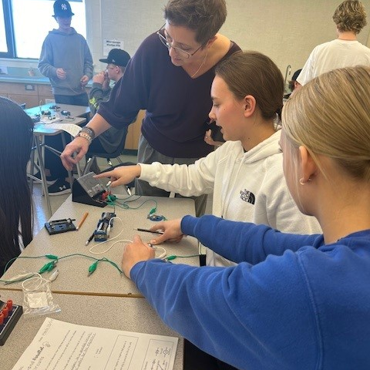

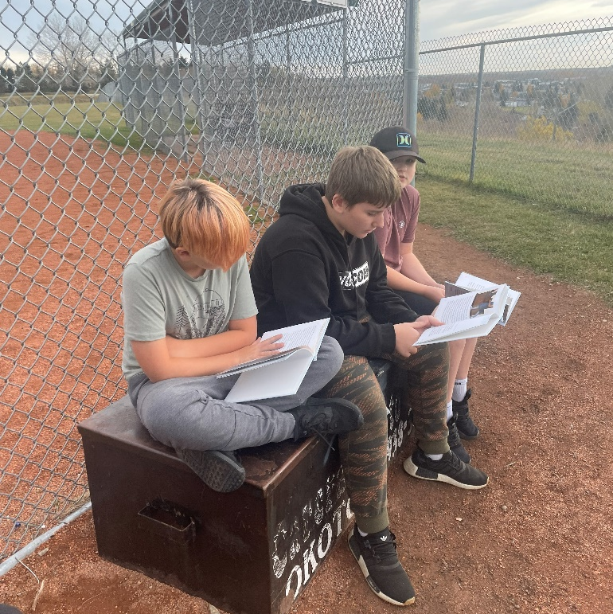
OUR STORY OF SUCCESS:

Literacy and Numeracy
At EOJHS we are strengthening student growth and achievement by consistently using provincial and local literacy and numeracy assessments (in English and French) to inform teacher practice and guide targeted, school-based interventions. At the same time, we are advancing high-quality numeracy resources and programming—leveraging approaches such as Building Thinking Classrooms and effective math interventions—to deepen student learning. This work is supported by increased use of the Staff Learning Link, empowering teachers to design and implement effective, evidence-based resources that lead to improved student outcomes.

100%
of students passed the DELF language exam in French.
(DELF)
94%
of students scored at the Acceptable Standard in English Language Arts.
(ELA PAT)

93%
of students scored at the acceptable Standard in French Language Arts.
(FLA PAT)
Evidence of Success & Resources
- Principles of Practice for French Immersion
- Principles of Practice for Literacy
- Principles of Practice for Numeracy and Mathematics

Support Opportunities & Resources
- Policy 14: A Place for All
- Safe Positive Schools
- FSD Resilience
- Inclusive Learning
- Student Learning
- Indigenous Learning

91%
Parents indicate our schools are safe and caring spaces
(FSD Assurance Survey)
89%
Students report our schools are safe and caring spaces
(SOS-Q)
84%
Parents indicate students have access to supports
(FSD Assurance Survey)

87%
Students report positive peer relationships
(SOS-Q)

- Indigenous Learning
- Student Supports
- Supports for Families
- Community Supports

Student Growth and Achievement

Literacy and Numeracy
Goals | Outcomes | Indicators | Measures
Advance literacy and numeracy  Advance literacy and numeracy development for each learner across all subjects and grades for improved student growth, achievement, and success. | - Learners are literate and numerate.  - Learners develop literacy and numeracy competency through curriculum to form the foundation for successful and fulfilling lives.  - Learners achieve provincial learning outcomes, demonstrating strengths in literacy and numeracy.  - Continue to offer curriculum that provides students with literacy, numeracy, citizenship, and practical skills.  - Leverage comprehensive provincial assessments, including early years literacy and numeracy screening, to assess progress, identify learning challenges and monitor student success.  - Balanced literacy and numeracy programming advances student growth and achievement.  - Learners have high quality learning experiences in literacy and numeracy.  - Learners apply knowledge, understanding and skills in authentic contexts and situations for deep and transferrable learning. | - Measures indicate that students demonstrate knowledge, skills, and attitudes of a literate and numerate learner.  - Measures indicate improvement in learner’s ability to understand learning outcomes, demonstrated by strengths in literacy and numeracy, across all subjects and grades.  - Principles of Deep and Transferable Learning are evident in classroom practice and positively impact student growth and achievement in literacy and numeracy.  - Learners demonstrate transfer of learning.  - High quality learning opportunities and experiences support literacy and numeracy. | - Learning Outcomes (PAT & Diploma):  - Increase/maintain FSD performance results ‘At or ‘Above’ provincial average for Acceptable Standard and Standard of Excellence on grade 6 and 9 provincial achievement tests in Language Arts, Math, Social Studies, and Science.  - Increase/maintain FSD performance results ‘At or Above’ provincial average for Acceptable Standard and Standard of Excellence on Grade 12 diploma exams.  - Provincial Literacy and Numeracy Assessments:  - Assessment (Literacy): Provincial Grade 1 Literacy Assessment (LeNS), Grade 2 and 3 Literacy Assessment (CC3) and Numeracy Assessments (Grade 1-3 Numeracy Screening Assessments)  - Common Literacy Assessment (4-9): Increase percentage of students who are at or above grade level expectations.  - Common Numeracy Assessment (4-9): Increase percentage of students who are at or above grade level expectations.  - DELF (Speaking, Listening, Reading, and Writing assessment in French): Increase number of students completing the DELF exams (B1 in grade 9 and B2 in grade 12) and increase percentage of students who achieve above 50% on the assessment.

OUTCOMES TO CONSIDER

The specialized supports and services your child is receiving enables them to be a successful learner
Your child can access the following services in a timely manner at school when needed: Academic counselling (Grades 7 and 10)

Satisfaction with Program Access
High school students demonstrate the knowledge, skills and attitudes necessary for learning throughout their lifetime​

Life-Long Learning

Your child can access the following services in a timely manner at school when needed: Career Counselling (Grades 7 and 10)
Your child can access the following services in a timely manner at school when needed: Services (beyond regular instruction) that help students to read and write
Your child is taught the knowledge, skills and attitudes necessary for learning throughout their lifetime

Your child can access the following services in a timely manner at school when needed: School Library services
Results Analysis for Literacy and Numeracy | Previous Results (4-Year Data Trends and Key Insights)

Provincial Learning Outcomes: Provincial Achievement Tests (Grade 9)
Provincial  Achievement Tests | English Language Arts |  | Math |  | Social Studies |  | Science |  | French Language Arts
Achievement (%) | Acceptable | Excellence | Acceptable | Excellence | Acceptable | Excellence | Acceptable | Excellence | Acceptable | Excellence
2024-25 (School) | 93.8 | 26.9 | 69.8 | 16.3 | 71.3 | 23.3 | 81.3 | 20 | 92.6 | 0
2024-25 (Prov) | 82.4 | 13.1 | 60.6 | 16.4 | 71.0 | 20.1 | 80.4 | 24.8 | 78.7 | 9.7
Evaluation (Achievement) | VERY HIGH | HIGH | HIGH | HIGH | INTERMEDIATE | HIGH | INTERMEDIATE | HIGH | HIGH | VERY LOW
Evaluation (Improvement) | MAINTAINED | IMPROVED | IMPROVED | IMPROVED | DECLINED | IMPROVED | MAINTAINED | IMPROVED | IMPROVED | DECLINED

Common Literacy/Numeracy Assessments: Local Measures
Common Numeracy Assessment:  Grade 4 – 9 EICS | Grade 4 | Grade 5 | Grade 6 | Grade 7 | Grade 8 | Grade 9
2021-2024 | n/a | n/a | n/a | n/a | n/a | n/a
2024-2025 | N/A | N/A | N/A | 72 | 76 | 83
Evaluation | N/A | N/A | N/A | INTERMEDIATE | INTERMEDIATE | HIGH

Common French Immersion Language Assessment: Grade 9 & 12 DELF
 | Grade 9 | Grade 12
2021-2024 | n/a | n/a
2024-2025 | 100% | N/A
Evaluation | VERY HIGH | N/A
OUTCOMES TO CONSIDER
Your child is taught attitudes and behaviours to be successful at work when they leave school
Work Preparation
Access to Supports and Services
At school, there are appropriate supports and services available to your child to help with their learning​
When your child needs it, teachers at your child's school are available to help them ​
You can get the support you need from the school to help your child be successful in their learning
Your child can easily access programs and services at school to get help with schoolwork
Your child can get help at school with problems that are not related to schoolwork ​
How satisfied or dissatisfied are you with the opportunities your child has to learn about the following topics at school:
- Another Language
- Art​
- Drama​
Citizenship
Students at your child's school follow the rules
Students at your child's school help each other when they can​
Students at your child's school respect each other​
Your child is encouraged at school to be involved in activities that help the community
Your child is encouraged at school to try their best​
Program of Studies
Your child is learning what they need to know
The numeracy skills your child is learning at school are useful​
- Health​
- Music​
- Technology
Student Learning Engagement
The literacy skills your child is learning at school are useful
The numeracy skills your child is learning at school are useful​
Your child is learning what they need to know

Strategy Analysis
Strategy Implemented in 2024-2025 2025-2026 2026-2027 2027-2028 2028-2029
Literacy and Numeracy | EVALUATION
Strategy 1: Advance the use and consistent application of all provincial and local assessment measures (assessments in English and French literacy and numeracy) to inform teacher practice, school-based interventions, and support student growth and achievement. | HIGH
Strategy 2: Advance the development and application numeracy resources and programming to support student growth and achievement through the application and strategies such as Building Thinking Classroom and effective Math interventions. | HIGH
Strategy 3: Increase utilization of the staff learning link to support teacher design and implementation of effective resources that lead to improved student learning. | INTERMEDIATE

Data Analysis
In telling our story of success we look at the progress we made in advancing literacy and numeracy which includes looking at results of provincial literacy and numeracy assessments for grades 1 to 3, analyzing results from the Grade literacy assessment and the MIPI numeracy assessment. We also analyze results of Grade 6 and Grade 9 Provincial Achievement Tests and Grade 12 Diploma Exams. This data told us that:
- EOJHS students’ ability to understand learning outcomes, demonstrated by strengths in literacy and numeracy, across all subjects and grades has improved
- Collaborative analysis of common assessments has improved teacher practice and supported student growth and achievement
- School based interventions such as a Grade 9 Math prep class, and Grade 7 math and literacy interventions support student growth and achievement
- 99% of EOJHS teachers are satisfied with the professional leaning and collaborative culture at EOJHS and FSD
- Upward trends show that there are appropriate supports and services available to students to help with their learning​
- Upward trends demonstrate an increase in the number of students who can access the services beyond regular instruction that help students to read and write in a timely manner at school.
- The development and application of numeracy resources and programming to support student growth and achievement through the application and strategies such as Building Thinking Classroom and effective Math intervention has been effective
- EOJHS performance results ‘At or ‘Above’ provincial average for Acceptable Standard and Standard of Excellence on grade 9 provincial achievement tests in Language Arts, Math, and Science have maintained or Increased
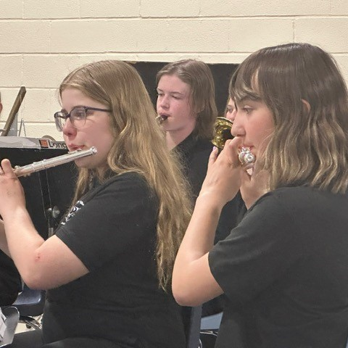

Our Story of Success:

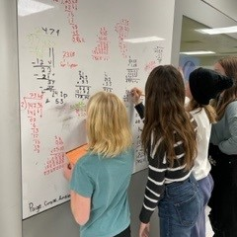
First Nations, Métis, and inuit student success

At EOJHS we are improving educational outcomes for First Nations, Métis, and Inuit students by strengthening system, program, and instructional supports while addressing systemic achievement gaps. Through the use of authentic, high-yield resources—including the Truth & Reconciliation for Learner Success Toolkit—we support meaningful teaching and learning connected to First Nations, Métis, and Inuit perspectives. Our work centers on cultivating safe, welcoming school cultures that foster belonging year-round by celebrating and sharing cultural knowledge beyond designated dates. Guided by the Truth and Reconciliation Commission’s Calls to Action, we are building student capacity for intercultural understanding, empathy, and mutual respect through trauma-informed and culturally responsive practices.

4
Four students and two staff members attended the Imagine a Canada Award Celebration in Winnipeg .
(Source)
92%
of students indicate they Agree or Strongly Agree that teachers have high expectations.
FSD Intellectual Engagement Survey

Support Opportunities & Resources
- Policy 14: A Place for All
- Safe Positive Schools
- FSD Resilience
- Inclusive Learning
- Student Learning
- Indigenous Learning

91%
Parents indicate our schools are safe and caring spaces
(FSD Assurance Survey)
89%
Students report our schools are safe and caring spaces
(SOS-Q)
84%
Parents indicate students have access to supports
(FSD Assurance Survey)

87%
Students report positive peer relationships
(SOS-Q)

- Indigenous Learning
- Student Supports
- Supports for Families
- Community Supports

90%
of self-identified indigenous students chose agree or disagree regarding the Personal Importance of Truth and Reconciliation.
Cultural Perspectives Survey
Evidence of Success & Resources
- Foothills School Division’s Truth and Reconciliation for Learner Success Toolkit
- Indigenous Learning
- Principles of Practice for Literacy
- Principles of Practice for Numeracy and Mathematics

First Nations, Métis, and Inuit Student Success
Support Opportunities & Resources
- Policy 14: A Place for All
- Safe Positive Schools
- FSD Resilience
- Inclusive Learning
- Student Learning
- Indigenous Learning

91%
Parents indicate our schools are safe and caring spaces
(FSD Assurance Survey)
89%
Students report our schools are safe and caring spaces
(SOS-Q)
84%
Parents indicate students have access to supports
(FSD Assurance Survey)

87%
Students report positive peer relationships
(SOS-Q)

- Indigenous Learning
- Student Supports
- Supports for Families
- Community Supports

GoalS | Outcomes | Indicators | MEASURES
Advance First Nations, Métis, and  Inuit student success  Advance First Nations, Métis, and Inuit student success by providing high quality instructional programs and educational services for our Indigenous students and to increase understanding and acceptance of Indigenous cultures for all students, staff, and community. | - First Nations, Métis and Inuit learners are successful.  - Engagement of First Nations, Métis and Inuit families in education and active participation in decision making to support student success and Truth and Reconciliation.  - Learners advance Truth and Reconciliation by acquiring and applying foundational knowledge of First Nations, Métis, and Inuit experiences.  - Enhance relationship-building between Indigenous communities and schools through community-based supports.  - Strengthen education programs, policies and initiatives for First Nations, Métis, and Inuit students.  - Support partners to gather, analyze and share Indigenous education data to monitor student success.  - The school community applies the resources needed to support First Nations, Métis, and Inuit student achievement. | - Evidence of programs, services, and strategies that support First Nations, Métis, and Inuit student success.  - Measures indicate all learners deepen their understanding of First Nations, Métis and Inuit perspectives, experiences, treaties, agreements, and the history and legacy of residential schools.  - Implementation of the FSD Truth and Reconciliation for Learner Success Toolkit supports improved Indigenous student success.  - Measures indicate improvements in attendance, achievement, and high school completion.  - Learners share positive experiences and conditions for success.  - Learners experience respectful and reciprocal relationships with their school community. | - Learning Outcomes (PAT & Diploma):  - Increase in FSD performance results ‘At or ‘Above’ provincial average for Acceptable Standard and Standard of Excellence on grade 6 and 9 provincial achievement tests in Language Arts, Math, Social Studies and Science for self-identified First Nations, Métis, and Inuit students.  - Increase in FSD performance results ‘At or Above’ provincial average for Acceptable Standard and Standard of Excellence on Grade 12 diploma exams for self-identified First Nations, Métis, and Inuit students.  - High School Completion Rate (AEAM): Increase in percentage of self-identified First Nations, Métis, and Inuit students who completed high school within five years of entering grade 10.  - Cultural Perspectives Survey: As part of the Student Intellectual Engagement Survey, we ask all students grades 4-12 their perspectives regarding diverse cultures including but not only First Nations, Métis, and Inuit peoples. This survey is further disaggregated to compare the general population’s perspectives with those self-identifying as First Nations, Métis, and Inuit peoples.  - SOS-Q (Student Orientation to School Questionnaire): Increase/maintain in percentage of students who are at or above the National Norm in the areas of Safe and Caring, External Resilience, Internal Resilience, Self-Confidence, Peer Relationships, Utility of School and Extracurricular Activities.  - Student Intellectual Engagement Survey: Increase/maintain percentage of students who chose to agree or strongly agree in 50% of questions in Grades 4 -12 in the areas: High Expectations, Relevance, Rigor, Effort, Lose Track of Time (ELA, Math, Social Studies, Science, CTF/CTS).  - Common Literacy and Numeracy Assessments (4-9): Increase percentage of students who are at or above grade level expectations.

RESULTS ANALYSIS  FIRST NATIONS, METIS, AND INUIT STUDENT SUCCESS | Previous Results (4-Year Data Trends and Key Insights)
AEA Measures for FNMI Students
 | SOS-Q Student Survey (Student Orientation to School Questionnaire): First Nations, Métis, and Inuit Students
 | Above National Norm
 | Performance Measure |  | Safe & Caring |  | External Resilience |  |  | Self Confidence |  | Internal Resilience |  | Peer Relations
 | 2024-2025 |  | 77% |  | 85% |  |  | 69% |  | 62% |  | 85%
 | Evaluation |  | HIGH |  | HIGH |  |  | INTERMEDIATE |  | INTERMEDIATE |  | HIGH
Intellectual Engagement Survey: First Nations, Métis, and Inuit Students
Students responding Agree or Strongly Agree to at least half of the questions each factor below |  |  |  |  |  |  |  |  | Students responding Agree or Strongly Agree to “I often lose track of time because I am engaged in the learning”
Performance Measures |  | High Expectations |  | Relevance |  | Rigor | Effort |  | ELA/SS |  | Math/Science |  | CTS
2024-2025 |  | 92 |  | 64 |  | 77 | 75 |  | 38/50 |  | 38/50 |  | 88
Evaluation |  | VERY HIGH |  | INTERMEDIATE |  | INTERMEDIATE | INTERMEDIATE |  | LOW |  | LOW |  | HIGH

Common Literacy/Numeracy Assessments: Local Measures
Common Numeracy Assessment:  Grade 4 – 9 EICS | Grade 4 | Grade 5 | Grade 6 |  | Grade 7 |  | Grade 8 |  | Grade 9
2021-2024 | n/a | n/a | n/a |  | n/a |  | n/a |  | n/a
2024-2025 | N/A | N/A | N/A |  | 67 |  | 50 |  | 100
Evaluation | N/A | N/A | N/A |  | INTERMEDIATE |  | LOW |  | VERY HIGH
Common Literacy Assessment:  Grade 4 – 9 EICS | Grade 4 | Grade 5 | Grade 6 | Grade 7 |  | Grade 8 |  | Grade 9
2021-2024 | n/a | n/a | n/a | n/a |  | n/a |  | n/a
2024-2025 | n/a | n/a | n/a | n/a |  | n/a |  | n/a
Evaluation | n/a | n/a | n/a | n/a |  | n/a |  | n/a

Cultural Perspectives Survey
% Students (4-12) Reporting Agree or Strongly Agree
Performance Measures | Cultural Belonging |  | Comfortable Sharing Culture |  | Encouraged and Accepted Sharing Culture |  | School Priority of Truth and Reconciliation |  | Personal Importance of Truth and Reconciliation |  | Cultural Infusion Across All Subject Areas |  | Understand Multiple Perspectives |  | Understand Truth and Reconciliation |  | Teachers Share Indigenous Perspectives
All Students (All) vs. Self-Identified Indigenous (SI) | All | SI | All | SI | All | SI | All | SI | All | SI | All | SI | All | SI | All | SI | All | SI
2024-2025 | 52% | 40% | 47% | 60% | 57% | 80% | 68% | 50% | 82% | 90% | 66% | 60% | 80% | 80% | 84% | 90% | 67% | 50%
Evaluation | L | L | L | I | I | H | INT | L | H | VH | I | I | H | H | H | VH | I | L
VL – Very Low L – Low I – Intermediate H – High VH – Very High
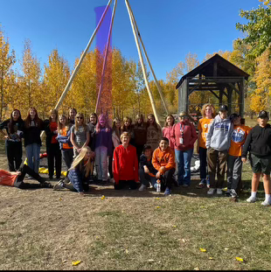

Data Analysis
In telling our story of success we look at the progress we made in advancing our goal of First Nations, Métis, and Inuit Student Success. We looked at the data from the SOS-Q Survey, Intellectual Engagement Survey, Math Intervention Programming Instrument, the Grade Literacy Assessment, the Cultural Perspectives Student Survey, and AEA Measures for First Nation, Metis and Inuit students. This data told us that:
- Utilizing authentic resources such as Blanket Exercise and visits by Elder Sakokoto who shared stories and his knowledge with Grade 8 students enhanced student learning and development
- Student capacity for intercultural understanding, empathy and mutual respect continues to increase
- Four students and two staff members attended the Imagine a Canada Award Celebration in Winnipeg , building capacity for intercultural understanding and Support the implementation of Truth and Reconciliation Commission recommendations
- Foods students grew edible plants growing plants and designing indoor and outdoor learning spaces through an indigenous lens is cultivating a sense of belonging through intentional development of safe and welcoming school cultures
- Successful in securing the project based Imagine a Canada grant application for an outdoor learning space
- Successful in securing The Western Financial Grant for advancing Truth and Reconciliation

Strategy Analysis
Strategy Implemented in 2024-2025 2025-2026 2026-2027 2027-2028 2028-2029
First Nations, Métis, and Inuit Student Success | EVALUATION
- Strategy 1: Improve education outcomes for First Nations, Métis, and Inuit Students through system, program, and instructional supports.  - Utilize authentic resources to support high-yield instructional tools and strategies by Accessing and sharing The Truth & Reconciliation for Learner Success Toolkit “Resources” page making available resources, within and outside the school community, to enhance student learning and development | INTERMEDIATE
- Strategy 2: Address the systemic education gap for self-identified First Nations, Métis, and Inuit students.  - Continued focus on cultivating a sense of belonging through intentional development of safe and welcoming school cultures by advancing, sharing, and celebrating First Nation, Métis, and Inuit cultural knowledge throughout school year beyond Sept 30th and June 21s | HIGH
- Strategy 3: Support the implementation of Truth and Reconciliation Commission recommendations.  - Build student capacity for intercultural understanding, empathy, and mutual respect through trauma informed practices and culture | HIGH

Our Story of Success:

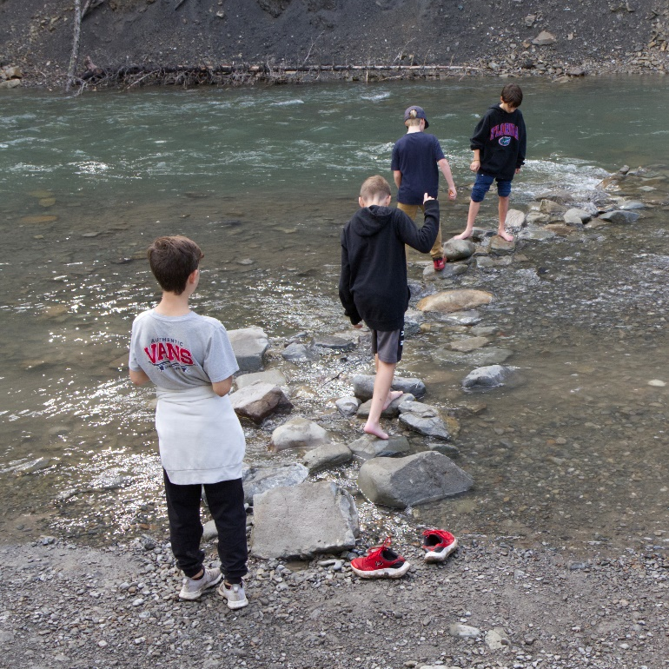
Teaching, Learning & LEADING

At EOJHS, we are strengthening teaching and leadership through meaningful professional learning that fosters collaboration and builds both individual and collective capacity. Grounded in educational research, this learning supports improved professional practice while encouraging educators to think critically, explore new approaches, and take thoughtful risks to enhance teaching and learning outcomes.

99%
99% of EOJHS teachers are satisfied with the professional leaning and collaborative culture at EOJHS
New FSD Professional Learning Survey (2024)

89%
of teachers agree or strongly agree that the Vision, Mission and Values are clear
New FSD Professional Learning Survey (2024)
(Source)

Evidence of Success & Resources
- Innovation and Design
- Learning that Transfers
- Truth and Reconciliation for Learner Success
- Indigenous Learning
- Principles of Practice for French Immersion
- Principles of Practice for Literacy
- Principles of Practice for Numeracy and Mathematics

Support Opportunities & Resources
- Policy 14: A Place for All
- Safe Positive Schools
- FSD Resilience
- Inclusive Learning
- Student Learning
- Indigenous Learning

91%
Parents indicate our schools are safe and caring spaces
(FSD Assurance Survey)
89%
Students report our schools are safe and caring spaces
(SOS-Q)
84%
Parents indicate students have access to supports
(FSD Assurance Survey)

87%
Students report positive peer relationships
(SOS-Q)

- Indigenous Learning
- Student Supports
- Supports for Families
- Community Supports

Teaching, Learning and LEADING Goals
Goals | Outcomes | Indicators | Measures
Advance excellence in teaching, learning, and leading  Advancing student growth and achievement through a sustained focus on optimizing teaching, learning and leading where teachers and leaders are committed to; professional collaboration, reflective practice, and continual improvement of instruction and assessment within dynamic and complex learning environments and contexts. | - Cultivating a culture of high expectations for all students and staff to optimize student learning and achievement.  - Teachers and leaders respond with skill and competence to the unique learning needs, interests, and cultural, social, and economic circumstances of all learners.  - Collaboration and reflective practice amongst teachers, leaders, students and their families, and other professionals enables optimum learning.  - Teachers and leaders improve their professional practice through collaborative engagement in processes of growth, supervision, and evaluation.  - Collaborating with other teachers and leaders to build personal and professional capacities and expertise.  - Professional learning is aligned to standards of professional conduct and standards of professional practice and leadership.  - Teachers and leaders use a range of data arising from their practice to inform cycles of %evidence-based continuous improvement.  - Improved systemic use of foundational principles of instruction, assessment and a common language of pedagogy.  - Curriculum is relevant, clearly articulated and designed for implementation within local contexts.  - Build professional capacity and a commitment to continuous improvement.  - Teachers grow their professional practice in design, instruction and assessment through professional learning, collaborative engagement, and reflective practice resulting in deep and transferable learning.  - Building the capacity of teachers to respond to the learning needs of all students.  - Teachers and leaders are accountable to a standard of professional conduct and a standard of professional practice. | Advance excellence in teaching, learning, and leading  Advancing student growth and achievement through a sustained focus on optimizing teaching, learning and leading where teachers and leaders are committed to; professional collaboration, reflective practice, and continual improvement of instruction and assessment within dynamic and complex learning environments and contexts. | - In-service jurisdiction needs (AEAM): Increase in the percentage of teachers reporting that in the past 3-5 years the professional development and in-servicing received from the school authority has been focused, systematic and contributed significantly to their ongoing professional growth.  - FSD Teacher Survey: teachers and leaders indicate growth in their professional practice to ensure optimum student learning and continuous improvement.

Results Analysis for Teaching and Leading | Previous Results (4-Year Data Trends and Key Insights)
New FSD Professional Learning Survey (2024): Teacher survey to measure impact of professional learning and collaborative structures in schools and across the system. |  |  |  |  | In-service jurisdiction needs  Provincial Measure
 | Clarity of Vision, Mission, and Values | Professional Learning and Collaborative Culture | Professional Learning Communities | Professional Body of Knowledge | School | Prov
2024-2025 | 91% | 99% | 84% | 81% | 69.4% | 81.7%
Evaluation | HIGH | VERY HIGH | HIGH | HIGH | VERY LOW

Data Analysis
In telling our story of success we look at the progress we made in advancing our goal of Teaching, Learning, and Leading. We looked at the data from the AEAM and our FSD Professional Learning Survey. This data told us that:
- Providing professional learning opportunities for teachers and leaders to collaborate, build personal and collective capacities and expertise in preferred areas of interest (Lines of Inquiry) results in teacher satisfaction in Professional learning .
- Staff commitment to planning of professional learning by being part of the School Leadership Team is effective
- Professional learning team collaboration to advance instructional practice and student learning is very high
- Strong engagement and connection between the school and community for Real-Real learning experiences is important
- Continued focus on innovative, authentic and worthwhile learning experiences for students to have more students in the FLOW range and reducing those reporting boredom, apathy or anxiety is needed

Strategy Analysis
Strategy Implemented in 2024-2025 2025-2026 2026-2027 2027-2028 2028-2029
Teaching and Leading | EVALUATION
Strategy 1: Providing professional learning opportunities for teachers and leaders to collaborate, build personal and collective capacities and expertise. | VERY HIGH
Strategy 2: Professional learning will apply educational research to improve professional practice. | VERY HIGH
Strategy 3: Encourages teachers to explore, take risks and think critically about their professional practice. | VERY HIGH

