WELCOME BACK CAYLEY COBRAS
Thoughts from the Counsellor-Ms April
As the sunny summer days get shorter and the curious wasps keep buzzing, it’s a reminder to reflect on how we got “here”. We made it through another school year and another summer and now we have arrived on the doorsteps of a fresh start once again. It’s a time to set some new goals, fall back into the structures and routines that guide us best and fill up those calendars with sporting events. But it’s also a time to normalize that going back to school and fresh starts can bring up some uncomfortable emotions. Perhaps it’s a new school, or just a new teacher in a new classroom that makes your child feel teary eyed and worried. Maybe it’s a peer they’re worried about seeing again or who they might play with at recess. Regardless of what or where those worries or fears are coming from, the list is long and it’s hard to watch our kids struggle through those uncomfortable emotions. Most of the time, uncomfortable emotions before a new event are to be expected and it’s okay to normalize them. It’s our bodies own alarm system waking us up to say ‘hey, there is something happening that I don’t know the outcome here so you better be paying attention’. Lots of times it’s that alarm system that keeps us safe and even motivates us. So, let’s work to embrace feeling uncomfortable when we can and trust that we can work through it when embracing it is just out of reach. The school is here to support you, so please reach out to us.
I love a good true crime podcast on long drives to pass the time, but my fall back into routine podcast is always listening to psychotherapist Lynn Lyons on Flusterclux. ( https://flusterclux.com/about-lynn-lyons-podcast/ ). Flusterclux has information that is easy to understand and relatable to any parent worried about anxiety. Topics include understanding anxiety, strategies for families to manage anxiety and other big emotions. Self-care tips for parents when they feel worry and exhaustion. And ways to increase family connection and joy. I just finished listening to the latest episode and I recommend you do too!
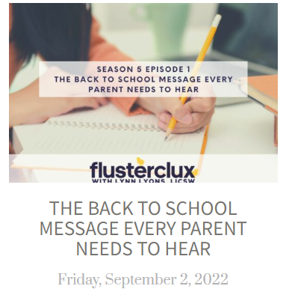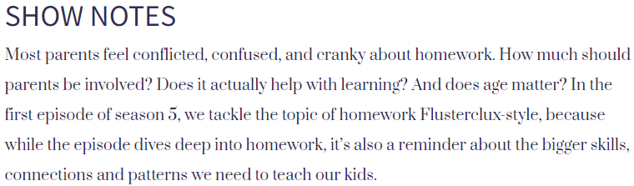
https://flusterclux.com/back-to-school-message/

